Datasafe with ORM stack

Contents

1. Introduction 3
2. Workflow diagram to deploy the stack 3
3. Create stack for Datasafe autonomous database 4
4. Plan the Job 7

Introduction

Oracle Data Safe is a fully-integrated Cloud service focused on the security of data. It provides a complete and integrated set of features for protecting sensitive and regulated data in Oracle Cloud databases. Features include Security Assessment, User Assessment, Data Discovery, Data Masking, and Activity Auditing.

Workflow diagram to deploy the stack

Below diagram shows how the Terraform Artifact are applied in the OCI. While creating a ORM stack, using terraform deliverables Init, Plan and Apply is the flow to provision the resource in the OCI. We can have the deliverables in any of below.

- GitLab/GitHub Repo
- Bitbucket
- Can be in folder/.zip in the local disk
- Object Storage Bucket
- Can be in compartment
- Oracle provided Template


Create stack for Datasafe

Go to OCI Console Developer Services Resource Manager Stacks select the compartment Create Stack

My Configuration Folder Browse Select the “Datasafe” folder that contains the terraform Upload

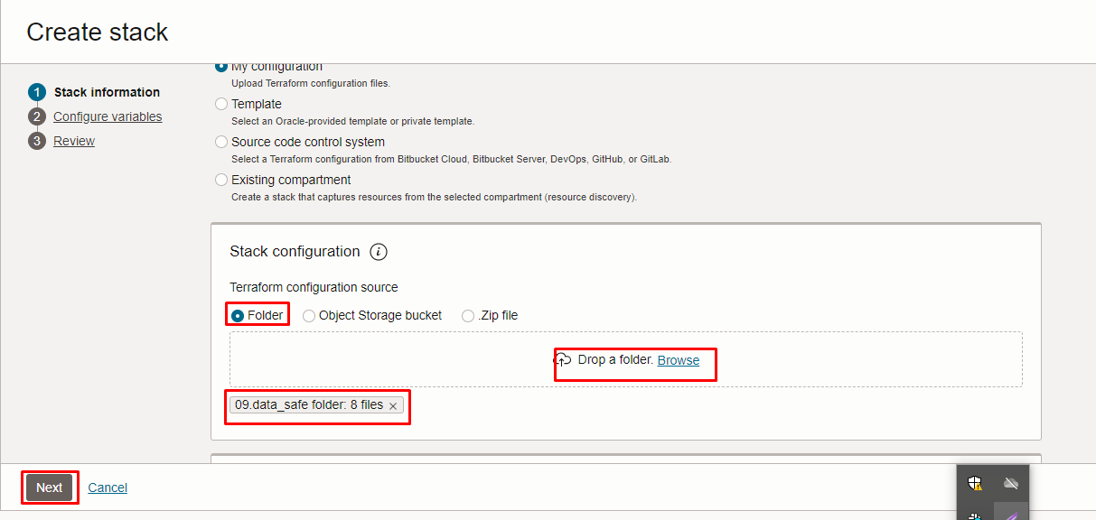

Select the parameters as per the below screen,
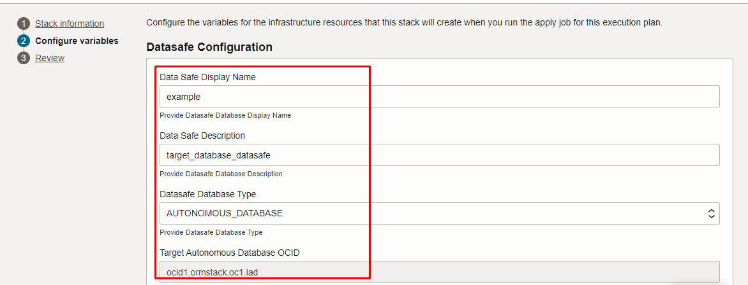

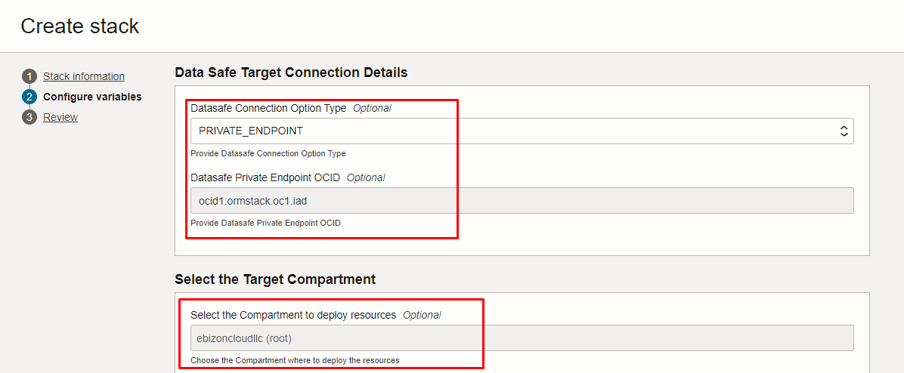

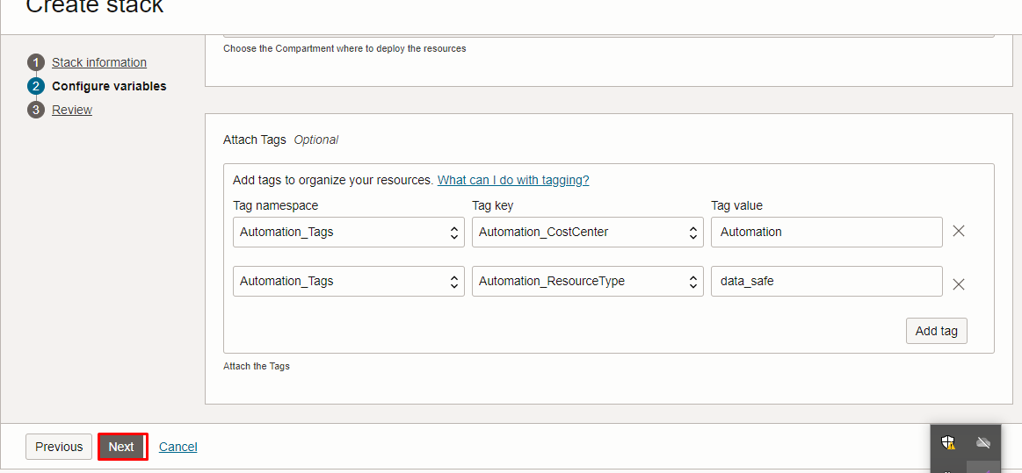

Click “NEXT”
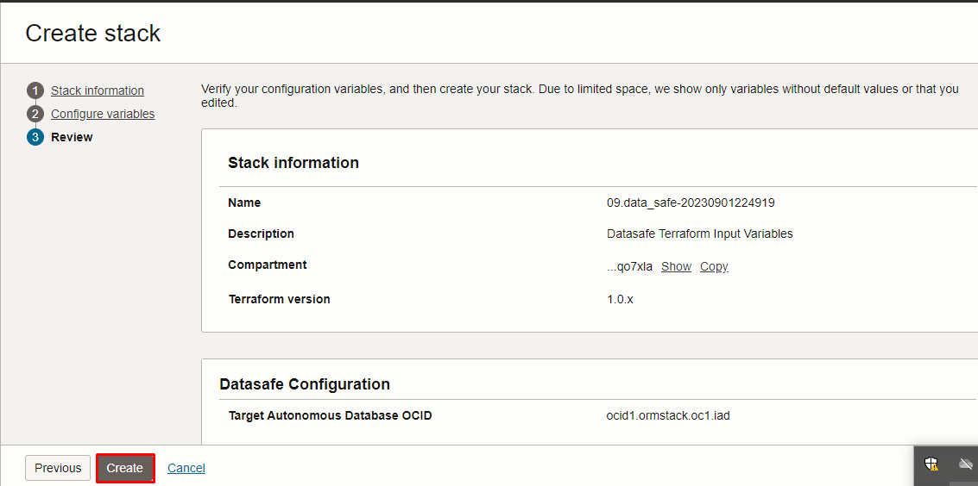
Click “CREATE”

Plan the Job

Click the “Plan”
